**Java Tasks**

**(ASSIGNMENT # 1 SEMESTER FALL-2023)**

**Submission Date (Sep 27, 2023)**

**By**

**MUHAMMAD IBTISAM AFZAL**

**Registration No.**

*FA22-BCS-073*

**Course Code (Course Title)**

*CSC241 (Object Oriented Programming) - Lab*

**Degree Program Title and Section**

*BCS-B*

**Submitted To**

*Mr. Shafqat*

**Department of Computer Science**



**COMSATS UNIVERSITY ISLAMABAD, SAHIWAL CAMPUS**

1. **Write a Java program to print prime numbers from 1 to 100.**

**Source Code:**

package task_1;

public class Main {

public static void main(String[] args) {

for (int i= 2; i <= 100; i++) {

int temp=0;

for (int j = 2; j <= i-1; j++) {

if (i % j == 0) {

temp=temp+1; }

}

if (temp == 0) {

System.out.print(i + " ");

}

}

}

}

**Output:**

1. **Write a Java program to compute the sum of the first 100 prime numbers.**

**Source Code:**

package task_2;

public class Sum_Prime_Numbers {

public static void main(String[] args) {

int count=0;

int sum=0;

while (count < 100) {

for (int i= 2; i <= 100; i++){

int temp=0;

for (int j = 2; j <= i-1; j++) {

if (i % j == 0) {

temp=temp+1; } }

if (temp == 0) {

sum =sum+i;

count++; } } }

System.out.print("The sum of first 100 Prime numbers is: "+sum); } }

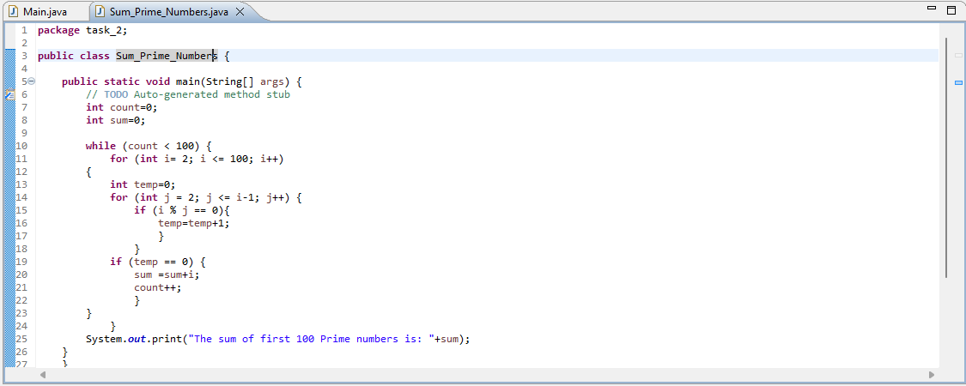

**Output:**

1. **Write a Java program to accept a number and check whether the number is even or odd.**

**Source Code:**

package task_3;

import java.util.Scanner;

public class Even_Odd {

public static void main(String[] args) {

Scanner scanner = new Scanner(System.in);

System.out.println("Enter a Number: ");

int number = scanner.nextInt();

if (number % 2 == 0) {

System.out.println(number + " is even.");

}

else {

System.out.println(number + " is odd.");

}

scanner.close();

}

}

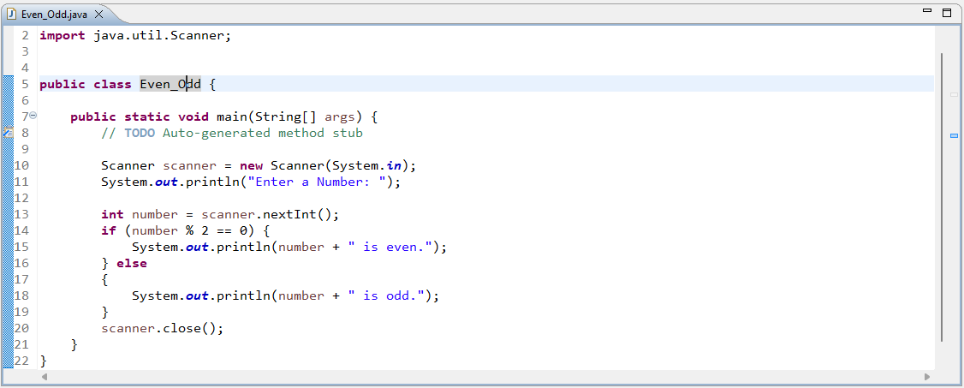

**Output:**

1. **Write a Java program to print numbers between 1 and 100 divisible by 3, 5 and both.**

**Source Code:**

package task_4;

public class Divisible_Numbers {

public static void main(String[] args) {

for(int i=1; i<=100;i++){

if(i % 3==0 && i % 5==0){

System.out.print(i +" ");}

} } }

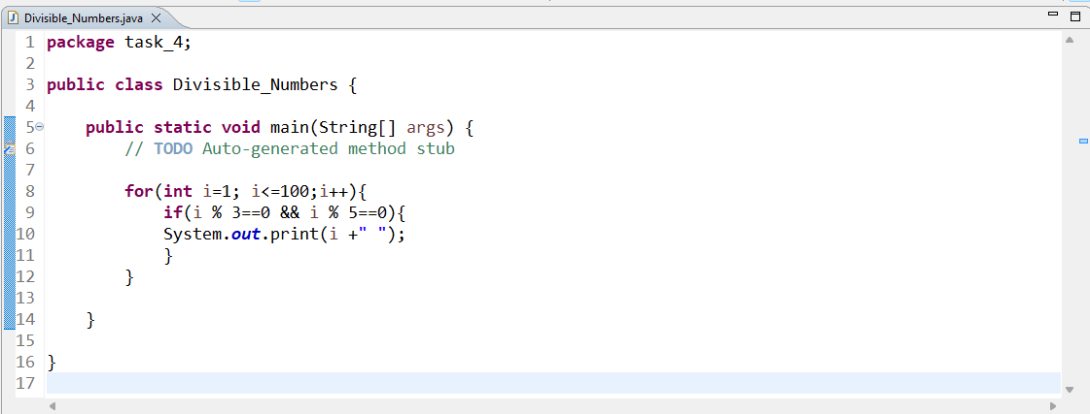

**Output:**

1. **Write a Java program to calculate the sum of two integers and return true if the sum is equal to a third integer.**

**Source Code:**

package task_5;

public class Sum_Equals_Third_Integer {

public static void main(String[] args) {

int num1=20, num2=40, num3=60, sum;

sum = num1+num2;

if (sum==num3) {

System.out.print("The sum of Two Integers = Third Integer"); }

else {

System.out.print("The sum of Two Integers != Third Integer");

}

}

}

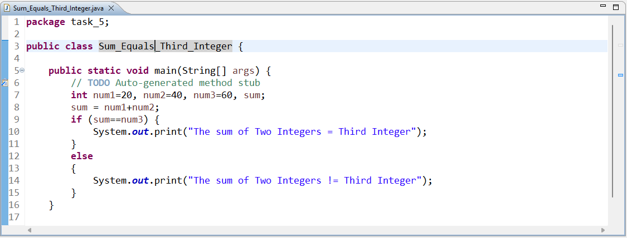

**Output:**

1. **Write a Java program to convert seconds to hours, minutes, and seconds.**

**Source Code:**

package task_6;

import java.util.Scanner;

public class Time_Converter {

public static void main(String[] args) {

Scanner scanner = new Scanner (System.in);

System.out.println("Enter seconds to convert: ");

float seconds = scanner.nextInt();

System.out.println("Time in Minutes: "+seconds/60);

System.out.println("Time in Hours: "+seconds/3600);

}

}

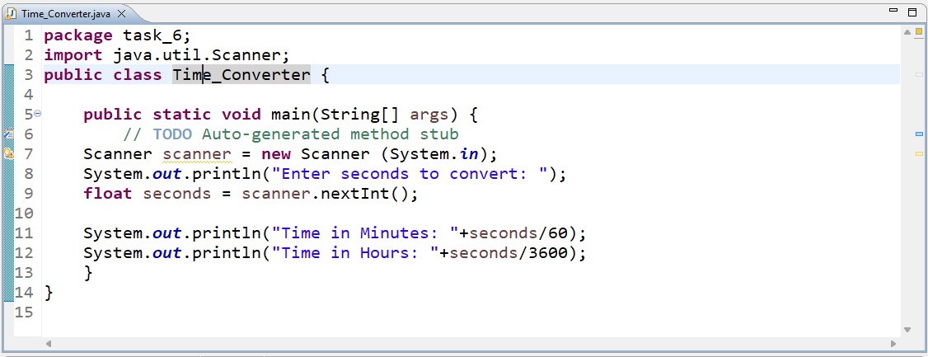

**Output:**

1. **Java program to print the numbers from a given number n till 0 using recursion.**

**Source Code:**

package task_7;

import java.util.Scanner;

public class Recursion {

public static void main(String[] args) {

Scanner start = new Scanner (System.in);

System.out.print("Enter a starting number: ");

int n = start.nextInt();

for(int i=n; i>=0; i--) {

if (n>=0) {

n--;

System.out.print(+i + " ");

}

}

}

}

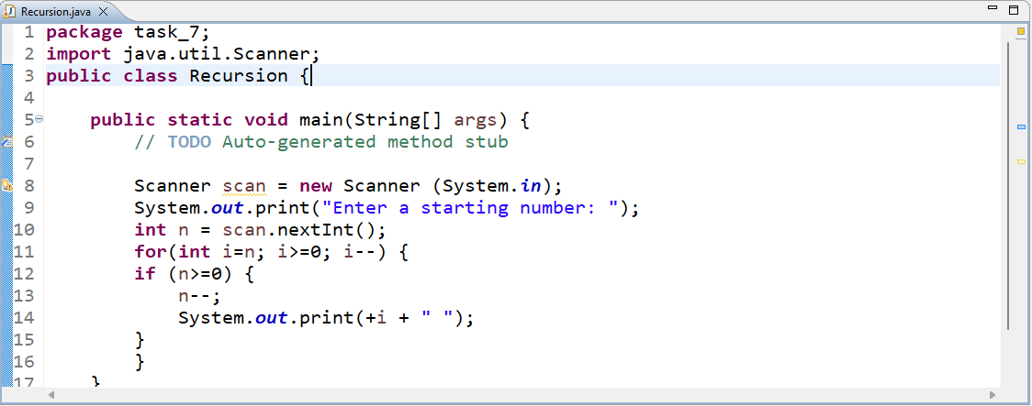

**Output:**

1. **Write a Java program to reverse an array of integers.**

**Source Code:**

package task_8;

public class Reverse_Array {

public static void main(String[] args) {

int []arr= {2,4,6,8,10,12};

for(int i=0;i<arr.length;i++) {

System.out.print(arr[i] +" ");

}

System.out.println();

int i=0, j=arr.length-1;

int temp=arr[i];

arr[i]=arr[j];

arr[j]=temp;

i++;

j--;

for(i=0; i< arr.length; i++) {

System.out.print(+arr[i]+" ");

}

} }

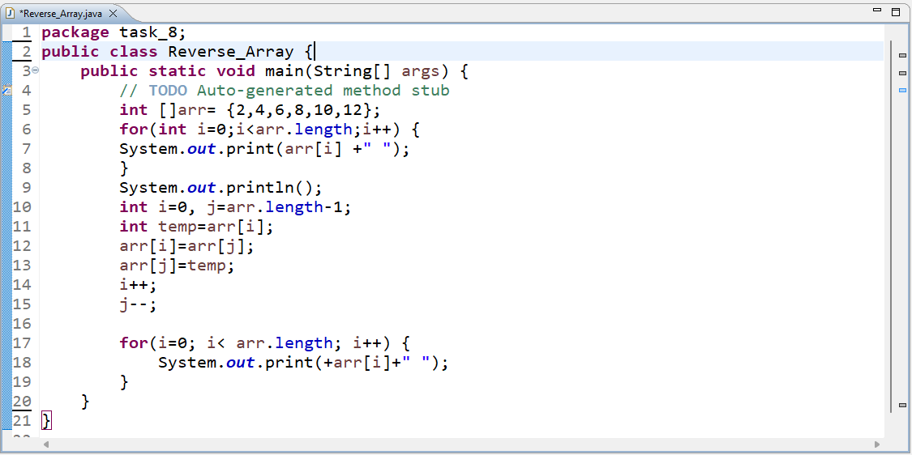

**Output:**

1. **Write a Java program to find the duplicate values in an array.**

**Source Code:**

package task_9;

public class Find_Duplicates {

public static void main(String[] args) {

int []arr= {1,2,3,3,2,6};

System.out.println("Duplicate elements found are: ");

for(int i=0; i<arr.length; i++) {

for(int j=i+1; j<arr.length; j++) {

if(arr[i]==arr[j]) {

System.out.println(arr[j]);

}

}

}

}

}

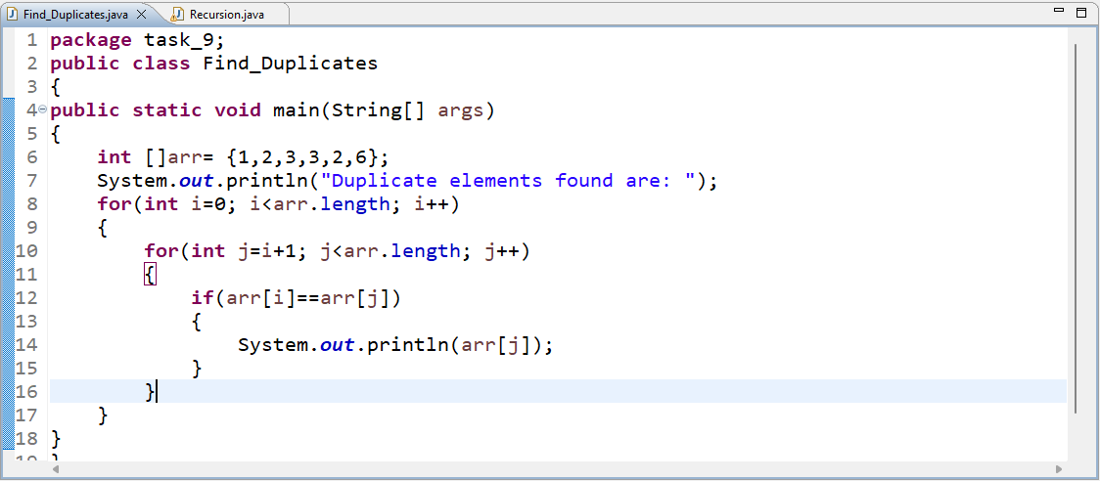

**Output:**

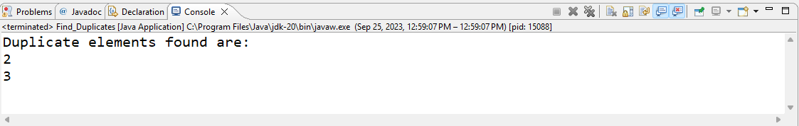

1. **Write a Java program to create a single array of any length by merging 2 integer arrays. The newly created array will contain the elements of both the first and second array.**

**Source Code:**

package task_10;

import java.util.Arrays;

public class Merging_Arrays {

public static void main(String[] args) {

int [] a = {1,2,3};

int [] b = {4,5,6};

int [] c = new int[a.length + b.length];

for (int i=0; i<a.length; i++) {

c[i]=a[i]; }

for(int i=0; i<b.length; i++) {

c[i + a.length] = b[i];

}

System.out.println(Arrays.toString(c));

}

}

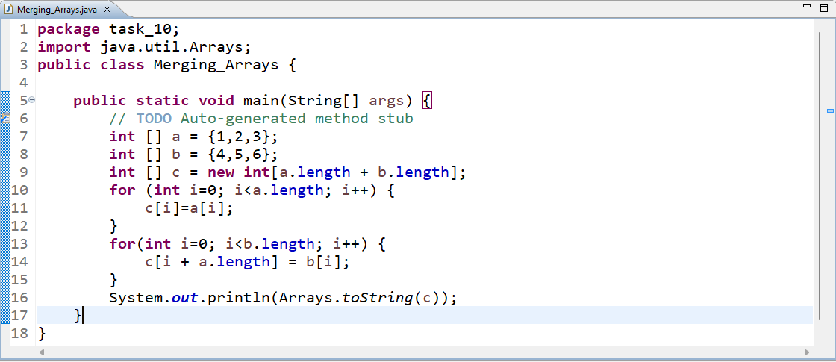

**Output:**

